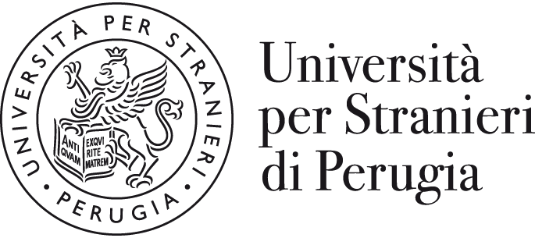 | INTERNATIONAL MOBILITY  Data Sheet “2026/2027”
Name of University | Università per Stranieri di Perugia  University for Foreigners of Perugia
Erasmus code | I PERUGIA 06
Website | www.unistrapg.it
Address | Piazza Fortebraccio 4 – 06123 Perugia (ITALY)
Departments | Dipartimento di Scienze Umane e Sociali Internazionali  Dipartimento di Lingua, Letteratura e Arti italiane nel mondo
Head of Institution | Prof. Valerio de Cesaris (Rector)  E-mail: rettore@unistrapg.it
International mobility Institutional Coordinator | Prof.ssa Federica GUAZZINI  E-mail: federica.guazzini@unistrapg.it
Head of Erasmus and International Mobility office | Mr Francesco LAMPONE  E-mail: erasmus@unistrapg.it

ERASMUS AND INTERNATIONAL MOBILITY OFFICE: CONTACTS
General e-mail address for enquiries | erasmus@unistrapg.it
Exchange agreements | Mr Filippo CAPRUZZI  Tel: +39 (0)75 5746266  E-mail: erasmus@unistrapg.it
incoming students advisor | Mr Filippo CAPRUZZI  Tel: +39 (0)75 5746266  E-mail: erasmus@unistrapg.it
outgoing students advisor | Mr Paolo FEI  Tel: +39 (0)75 5746301  E-mail: erasmus@unistrapg.it
Staff mobility (teaching/training) | Mr Paolo FEI/ Mr Filippo CAPRUZZI  Tel: +39 (0)75 5746301/266  E-mail: erasmus@unistrapg.it
Website for international students | https://www.unistrapg.it/mobilita-internazionale/mobilita-entrata/altre-mobilita-fini-di-studio-ingresso

DEGREE COURSES
Academic Calendar (Degree Courses) | Autumn semester: beginning of October to end of December  Spring semester: beginning March to end of May
Examination Periods (Degree Courses) | Autumn semester: January/February  Spring semester: June/July
Recommended arrival dates  (probable dates) | Autumn semester: Last week of September  Spring semester: Last week of February
Language of courses | Italian
Courses taught in English | Yes
Average credit load per course (ECTS) | 3 or 6 or 9

EXCHANGE RELATED INFORMATION
Nomination deadlines | Autumn semester: 30 June  Spring semester: 30 November
Application deadlines | Autumn semester: 31 July  Spring semester: 30 December
Application for international students | Electronic Paper-based
Website for exchange application information | https://www.unistrapg.it/mobilita-internazionale/mobilita-entrata/altre-mobilita-fini-di-studio-ingresso
Online application for ordinary courses in Italian language and culture | https://www.unistrapg.it/offerta-formativa/corsi-di-lingua-e-cultura-italiana
Contact Person for application information  Tel./ E-mail | Secretary office for the language courses  E-mail: corsidilingua@unistrapg.it

DEGREE AND MASTER DEGREE COURSES ON OFFER
https://www.unistrapg.it/offerta-formativa/corsi-di-laurea-e-laurea-magistrale
First level degree courses | Corso di laurea in Comunicazione internazionale e pubblicitaria (ComIP)  Corso di laurea in Lingua e cultura italiana nel mondo digitale (LiCIMoD)  Corso di laurea in Made in Italy, cibo e ospitalità (MICO)  Corso di laurea in Scienze sociali per la sostenibilità e la cooperazione internazionale (SoCI)
Second level degree courses | Corso di laurea magistrale in Comunicazione pubblicitaria, storytelling e cultura d'immagine (ComPSI)  Corso di laurea magistrale in Italiano per l'insegnamento a stranieri (ItaS)  Corso di laurea magistrale in Relazioni internazionali e cooperazione allo sviluppo (RICS)

Language of instruction
All the courses offered within the first and second level degrees are taught in Italian language.
The minimum level recommended for incoming student to attend classes of Degree courses is B2.

Students with a poor knowledge of the Italian language (A1 and A2) are invited to attend courses in Italian language and Culture and improve their linguistic abilities before starting attending degree and master degree courses

COURSES IN ITALIAN LANGUAGE AND CULTURE FOR FOREIGNERS
Academic Calendar | Courses are available all the year, the official schedule is available at:  https://www.unistrapg.it/offerta-formativa/corsi-di-lingua-e-cultura-italiana/informazioni-gli-studenti-sui-corsi-di-lingua-e-cultura-italiana/calendario-didattico-dei-corsi-di-lingua-e-cultura-italiana
Examination Periods  (Language courses) | March, June, September and December  (at the end of three-months ordinary courses)
Average credit load per course (ECTS) | Monthly courses: 6 ECTS (levels A1-B2)  Monthly courses: 8 ECTS (levels C1-C2)  Three-months courses (level A1 to B2): 20 credits  Three-months courses (level C to C2): 30 credits
Cost | Free of charge for exchange students

HOUSING RELATED INFORMATION
Contacts | Secretary office for the language courses  E-mail: corsidilingua@unistrapg.it
Website | https://www.unistrapg.it/offerta-formativa/corsi-di-lingua-e-cultura-italiana/informazioni-gli-studenti-sui-corsi-di-lingua-e-cultura-italiana/alloggi

IMPORTANT:
All incoming exchange students from non-UE countries must be in possess of the Visa for Study purpose to be accepted.

